**Part B**

Using your knowledge from lab 4 and the Bash Shell Scripting module(s) create a script which will accomplish the following:

1. The script will create a directory that was been provided by the user*, using the security levels also provided by the user.
2. Create the number of files, name of the files, and security levels for the files as provided by the user*.

* - Provided by the user means requesting the information from the user, not hard coding the information.

Turn in (compress with zip compression, into one zip file)

1. The script code (A3-1)
2. The results of running the script code as seen in the terminal window. Make sure to show all directories, files, and security created. (A3-2)

(A3-1)

(A3-2)



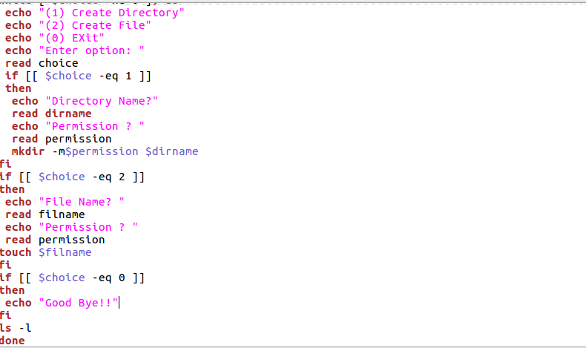

(A3-2)

